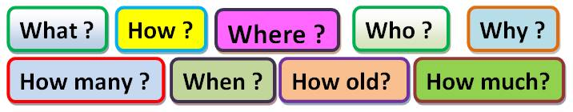
•Complete the sentences with the correct Wh-word .
______________ are you excited? because I have birthday today.
______________ are you today ? I’m fine ,thank you.
______________ is your coat ? in the bedroom
______________ is she at the moment? at home
______________ is your birthday ? in September
______________ is Mr. Bean ? 55 years old
______________ is that woman? She is our sport teacher.
______________ are they working? in the book shop
______________ apples do you have ? three apples
______________ are the children? in the swimming pool
______________ is Rita doing ? She is watching TV now.
______________ does your car cost ? 2.000 $ dollars
______________ time is it ? It’s nine o’clock.
______________ are the kids sad? because they don’t go to the cinema.
______________ is the party? at 5 o’clock
______________ friends do you have? I have two good friends.
______________ do they go to school? by bus
______________ do you eat lunch? in the afternoon
______________ is on the desk? a new notebook
______________ is in the kitchen? my little brother

